**4 Setting up differential equations (Measles)**

Set up the SEIR model of the transmission dynamics of measles in a closed population using ***differential*** equations:



We assume that individuals mix randomly and parameter values are given as follows:

Population 100,000 people

Pre-infectious period 8 days

Infectious period 7 days

Basic

Life Expectancy 70 years

Initial values (S,E,I,R)=(99999,0,1,0)

**PART I: Setting up differential equations**

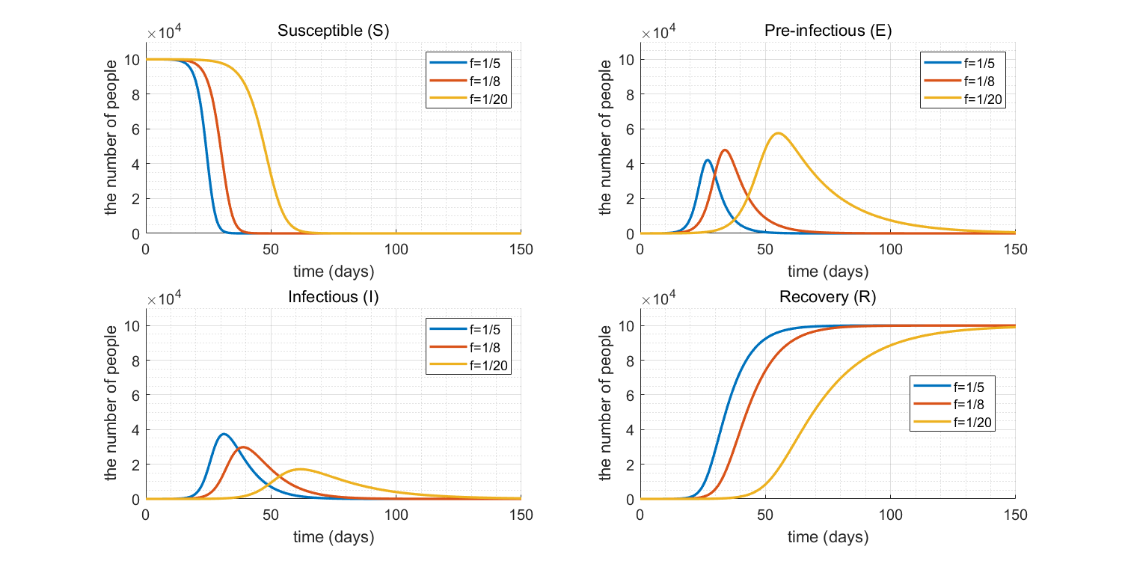

1. Plot a graph for number of susceptible, pre-Infectious, infectious, and recovered populations during 150 days.
2. How does the graph change if you change the pre-infectious period to be 5 days and 20 days, respectively?

The outbreak occurs sooner in the case of 5 days pre-infectious period. In contrast, when the pre-infectious period gets larger, we would have the outbreak later. Also, the peak number of infectious people goes down with the increasing pre-infectious periods.

1. What happens to the size of the epidemic (as reflected in the number of people who are immune at the end) as the pre-infectious period is increased? What happens as it is decreased?

On day 150, the final number of immune people is 10,000, 10,000, and 99,009, as the pre-infectious period is increased, respectively. It seems there are slight differences when the pre-infectious period is 20 days. However, if we simulate this prediction model with a longer time scope (a year), the final epidemic size of the 20-day pre-infectious case also has 10,000.

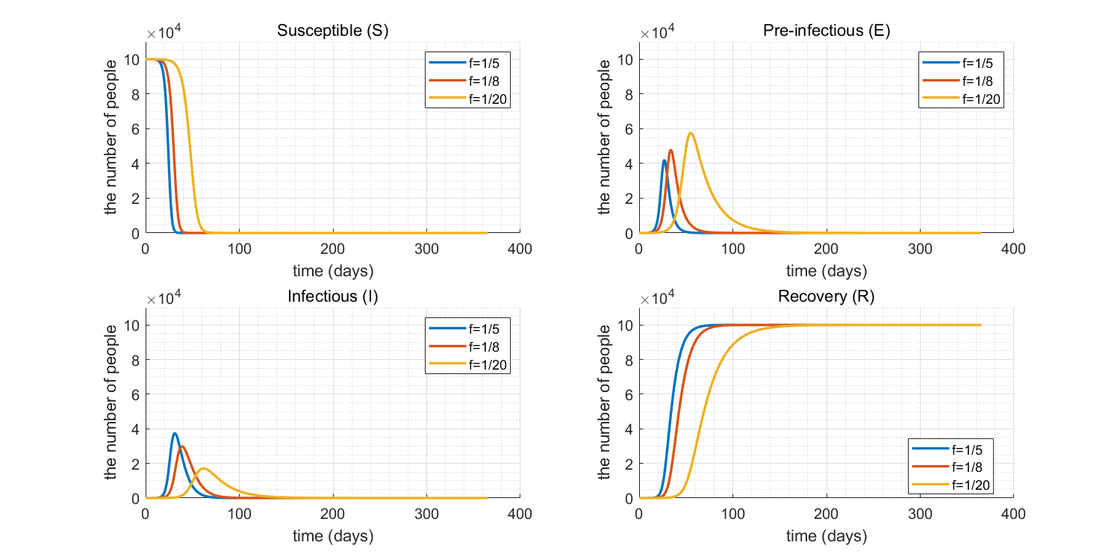

In this sense, the size of the epidemic does not change even if the pre-infectious period changes variously.

**PART Ⅱ: Incorporating births and deaths**

Modify the model to include the births and deaths in each time step and change the parameter values back to original: (100 years)

1. How do the general patterns in the numbers of susceptible and immune individuals differ from those predicted using *the difference equations in the last practical?*

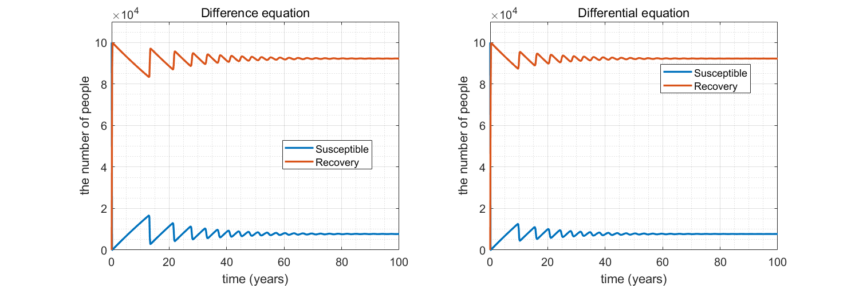

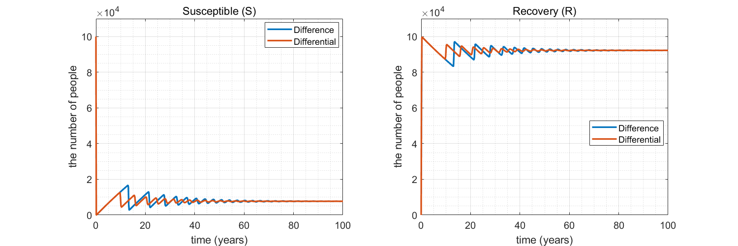

1. You should notice that, although the daily number of new infectious persons and the numbers of susceptible and immune individuals oscillates over time, these oscillations become weaker, and they seem to disappear entirely. This pattern is inconsistent with what happens in many populations in which measles vaccination has not been introduced, measles epidemics occur every two years, which suggests that other factors help to sustain the epidemic cycles. ***Suggest*** possible factors which might help to determine the regular patterns in measles cycles.

Answer: When the number of susceptible becomes sufficiently large enough (above the herd-immunity threshold), an outbreak occurs and we get back closer to where we started. This cycle continues until we eventually converge towards the herd-immunity threshold.

The figure above is a graph of the actual data. Unlike our theoretical graph, there seems to be no convergence before the introduction of the MMR vaccine.

Cycles occur because major epidemics extinguish themselves by exhausting their supply of susceptible individuals; the numbers of individuals in at-risk groups then build up slowly, eventually providing enough scope for the next major outbreak (Nature).

To make our graph more similar to the actual data, there are several things we can do. We could incorporate seasonal factors because there is more contact between students during the school term rather than the holidays. We could also incorporate age-specific compartments. Our model was deterministic but using stochastic assumptions could help explain what is lacking in our model. Also, in our model, birth and death rates were constant, but this may not be a valid assumption. The reason is that, in reality, there are also cycles in population with some generations having more people than others.